Logging_using_SLF4J_Hands_On_Exercise

Exercise 1: Logging Error Messages and Warning Levels
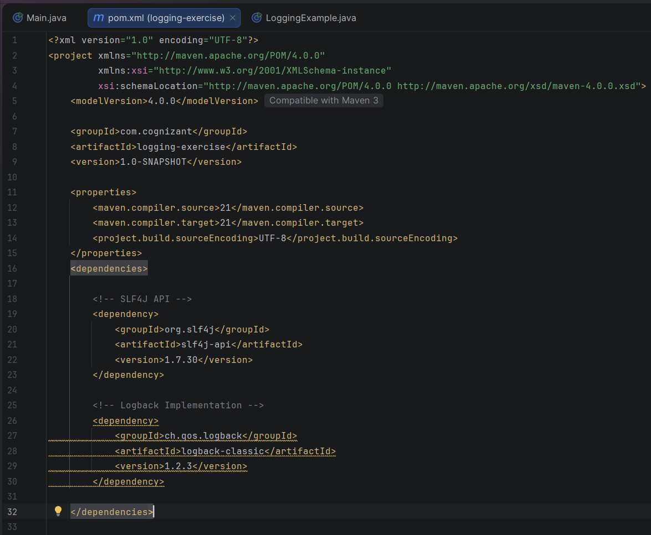
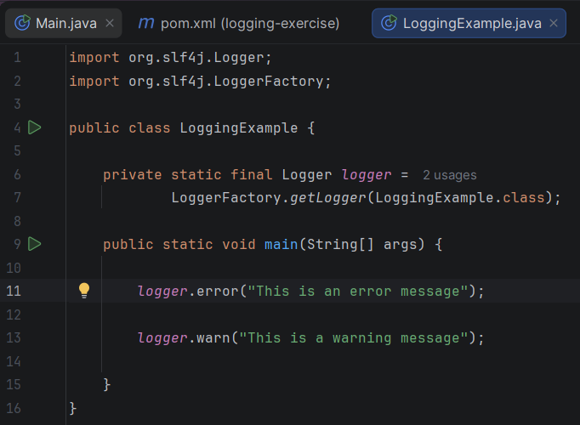

Output:
